**Signal to Noise Ratio and Contrast to Noise Ratio**

# Introduction

The purpose of this project is to explore Signal-to-Noise Ratio (SNR) and Contrast-to-Noise Ratio (CNR) in CT imaging. SNR measures the strength of the signal relative to the noise, while CNR evaluates the contrast between different structures or tissues relative to the noise level (**Fig 1.**).

In this project, we will focus on calculating the SNR and CNR within specific regions of interest (ROI) in CT images with a Cone-shaped Finger Phantom (**Fig 2.**).

Signal-to-Noise Ratio (SNR) is used to evaluate the clarity of the CT image. It is defined as:

$$\begin{aligned}SNR=\frac{μ_{o}}{σ_{o}}\#\left(1\right)\end{aligned}$$

where $μ_{o}$ is the mean attenuation coefficient of a defined structure (object) in the region of interest, $σ_{o}$ is the noise expressed as a variance of the pixel value of the targeted region of interest.

Contrast-to-Noise Ratio (CNR) is a measure used to specify image quality. It is defined as:

$$\begin{aligned}CNR=\frac{μ_{O}-μ_{B}}{\sqrt{σ_{o}^{2}+σ_{B}^{2}}}\#\left(2\right)\end{aligned}$$

where $μ_{B}$ is the mean attenuation coefficient of the image background surrounding this structure and $σ_{B}$ is the general background noise expressed as a variance of pixel value outside of the targeted region of interest.

|  |
| --- |
|  |
| ***Fig 1.*** *Plot of CT attenuation coefficient (μ) across an object of interest (O) surrounded by a background (B). The contrast is the difference in the average attenuation coefficients. The background noise is the standard deviation in the value of μ_B. Higher noise levels may still allow for an accurate diagnosis provided the noise level is not too excessive in comparison with contrast (∆μ>> σB) of a target region of interest* |

# EXPERIMENT

## Materials

* Cone-shaped Finger phantom (**Fig 2a**)
* 2L water
* DeskCAT Multi-slice Optical CT Scanner
* Collimator mask (**Fig 2b**)

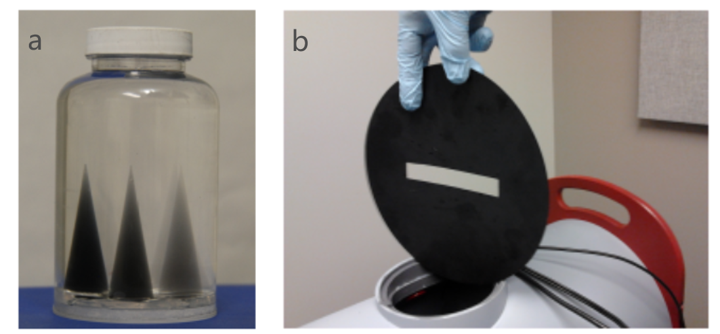

***Fig 2.*** *Cone-shaped finger phantom and collimator mask*.

## Experimental Procedure

1. Install a **Collimator mask** in front of the camera to capture data from the central slice. Please ensure that the slit in the collimator remains horizontal.
2. Adjust the camera setting to 50% of maximum brightness (reducing the brightness allows for evenly distributed noise) by selecting **Scanner -> Camera Settings (Fig 3.)**. **You can simulate different exposure times by adjusting this bar, to obtain projection data with varying doses.**

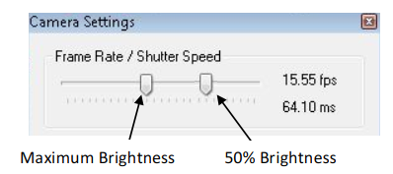

***Fig 3.*** *Camera setup diagram*

1. Under **Calibration $→$ Geometry Calibration** select Auto-Cal and accept the values. Calibration must be done with NO phantom loaded.
2. Set the Number of projections on the side panel to acquire data.
3. Do not place phantom $→$ click on the left sidebar to **scan reference data**.
4. **Load the Finger Phantom** into the scanner by attaching the phantom to the Rotary Stage using the Jar Clamp and mounting the Rotary Stage onto the scanner. Acquire a Data Scan using the Start Data Scan button on the Side Panel. Wait for the scan to complete.
5. Under Reconstruction $→$ Reconstruction Options, select **Hamming Filter.**
6. Select the Voxel Resolution option and press Start Reconstruction to perform a reconstruction. Observe the reconstruction results using the software.

# Reconstruction

## Dataset

Based on the aforementioned data acquisition steps, we collected raw data. The contents of the 'rawdata' folder are shown in **Fig 4**. The contents of the folder are explained as follows:

* ScanData: Projection data collected after placing the phantom.
* ScanRef: Projection data collected without the phantom in place.
* Calibration.xml: Geometric parameters.
* Info.xml: Contains the number of projections in ScanData and ScanRef.

|  |
| --- |
|  |
| ***Fig 4.***  *Example of the raw data folder.* |

## Reconstruction Steps

The reconstruction process consists of two parts: the preprocessing part and the reconstruction part.

The preprocessing part includes the following steps:

* Flat field correction
* Geometric correction

Note: The offsets provided by the system often have some deviation, requiring manual adjustment to achieve the best results.

Reconstruction part: You can use the methods in the ASTRA Toolbox ([The ASTRA Toolbox — ASTRA Toolbox 2.1.0 documentation (astra-toolbox.com)](https://astra-toolbox.com/)) for reconstruction, or you can find other methods for reconstruction, such as iterative reconstruction, and deep learning reconstruction. **HOWEVER, FBP RECONSTRUCTION RESULTS MUST BE PROVIDED!**

# Analysis

**Purpose**: This project is to explore the role and principles of CNR and SNR in evaluating image quality in CT scans.

**Task**: Your task is to carefully select relevant ROIs and perform calculations to compare the SNR and CNR among different ROIs in the reconstructed CT images. It is important to note that you will need to calculate the CNR values of other tissues using the **ROI with the highest SNR as a reference**. Specifically, you will focus on comparing the SNR and CNR values of various tissue ROIs in CT images. Subsequently, you will analyze the significance conveyed by these distinct values and engage in a comprehensive discussion regarding the underlying factors contributing to these observed differences. **Report your results in both qualitatively images as well as quantitative tables.**

# Additional Question

By using different camera exposure times, you can obtain raw data with different amounts of photons (i.e. ‘radiation’ doses). How will CNR and SNR change with ‘radiation’ dose?